ONEWAY Memory BY Gender1
/STATISTICS DESCRIPTIVES HOMOGENEITY WELCH
/PLOT MEANS
/MISSING ANALYSIS.

Oneway

Notes
Output Created |  | 05-May-2019 23:05:49
Comments
Input | Active Dataset | DataSet0
Input | Filter | <none>
Input | Weight | <none>
Input | Split File | <none>
Input | N of Rows in Working Data File | 30
Missing Value Handling | Definition of Missing | User-defined missing values are treated as missing.
Missing Value Handling | Cases Used | Statistics for each analysis are based on cases with no missing data for any variable in the analysis.
Syntax |  | ONEWAY Memory BY Gender1  /STATISTICS DESCRIPTIVES HOMOGENEITY WELCH  /PLOT MEANS  /MISSING ANALYSIS.
Resources | Processor Time | 00 00:00:00.203
Resources | Elapsed Time | 00 00:00:00.205

[DataSet0]

Descriptives
 | N | Mean | Std. Deviation | Std. Error | 95% Confidence Interval for Mean
 |  |  |  |  | Lower Bound | Upper Bound
Female | 6 | 114.9583 | 38.41953 | 15.68471 | 74.6395 | 155.2772
Male | 24 | 89.2642 | 31.15161 | 6.35880 | 76.1100 | 102.4183
Total | 30 | 94.4030 | 33.66618 | 6.14658 | 81.8318 | 106.9742

Descriptives
 | Minimum | Maximum
Female | 64.50 | 166.00
Male | 48.00 | 162.00
Total | 48.00 | 166.00

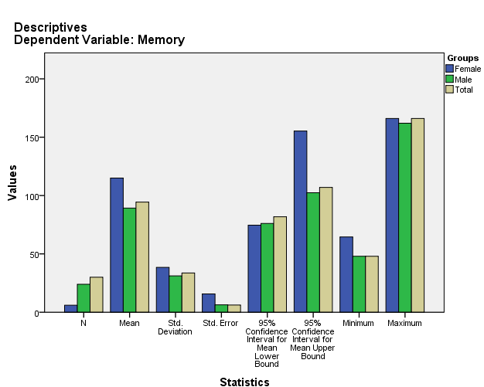

Test of Homogeneity of Variances
Memory
Levene Statistic | df1 | df2 | Sig.
.831 | 1 | 28 | .370

ANOVA
Memory
 | Sum of Squares | df | Mean Square | F | Sig.
Between Groups | 3168.913 | 1 | 3168.913 | 2.988 | .095
Within Groups | 29700.032 | 28 | 1060.715
Total | 32868.945 | 29

Robust Tests of Equality of Means
Memory
 | Statisticª | df1 | df2 | Sig.
Welch | 2.305 | 1 | 6.739 | .174
a. Asymptotically F distributed.

Means Plots

